Table of Contents

*Fixed - Current installed themes* 2

Classic 2

Blue 3

Glass 4

Material 5

Silver 6

Soft-blue 7

VS2010 8

*New Themes* 9

Caramel 9

Coffee 10

DevExpressStyle 11

Foggy 12

iMaginery 13

Lilian 14

LiquidSky 15

LondonLiquidSky 16

Material-Black 17

Material-Blue 18

Material-Green 19

Material-Maroon 20

Material-Navy 21

Material-Pink 22

Material-White 23

McSkin 24

Metropolis 25

MoneyTwins 26

Seven 27

SevenClassic 28

Springtime 29

Stardust 30

Summertime 31

TheBezier 32

TheAsphaltWorld 33

Valentine 34

WhitePrint 35

# *Fixed - Current installed themes*

## Classic

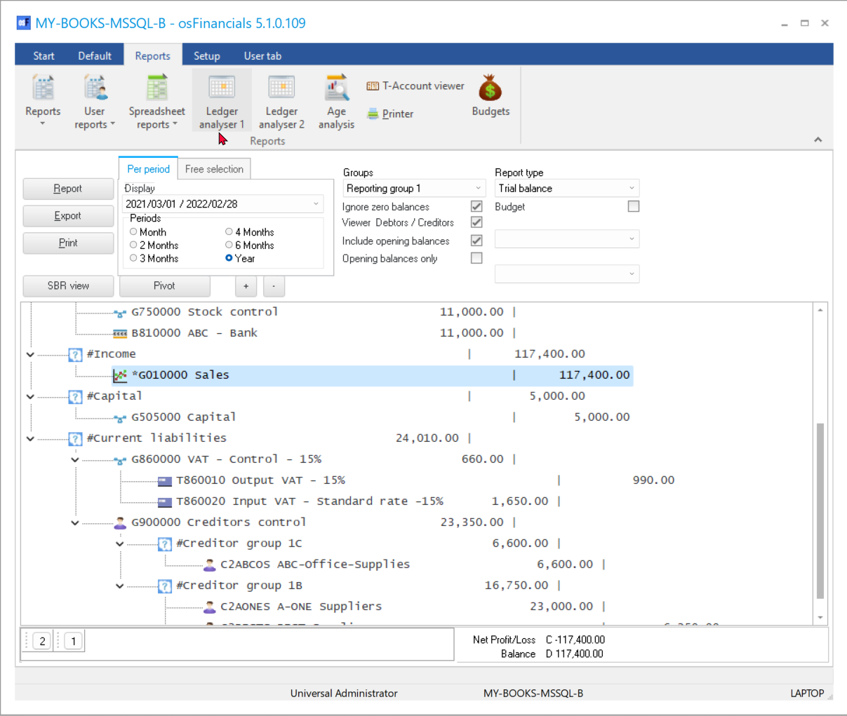

## Blue

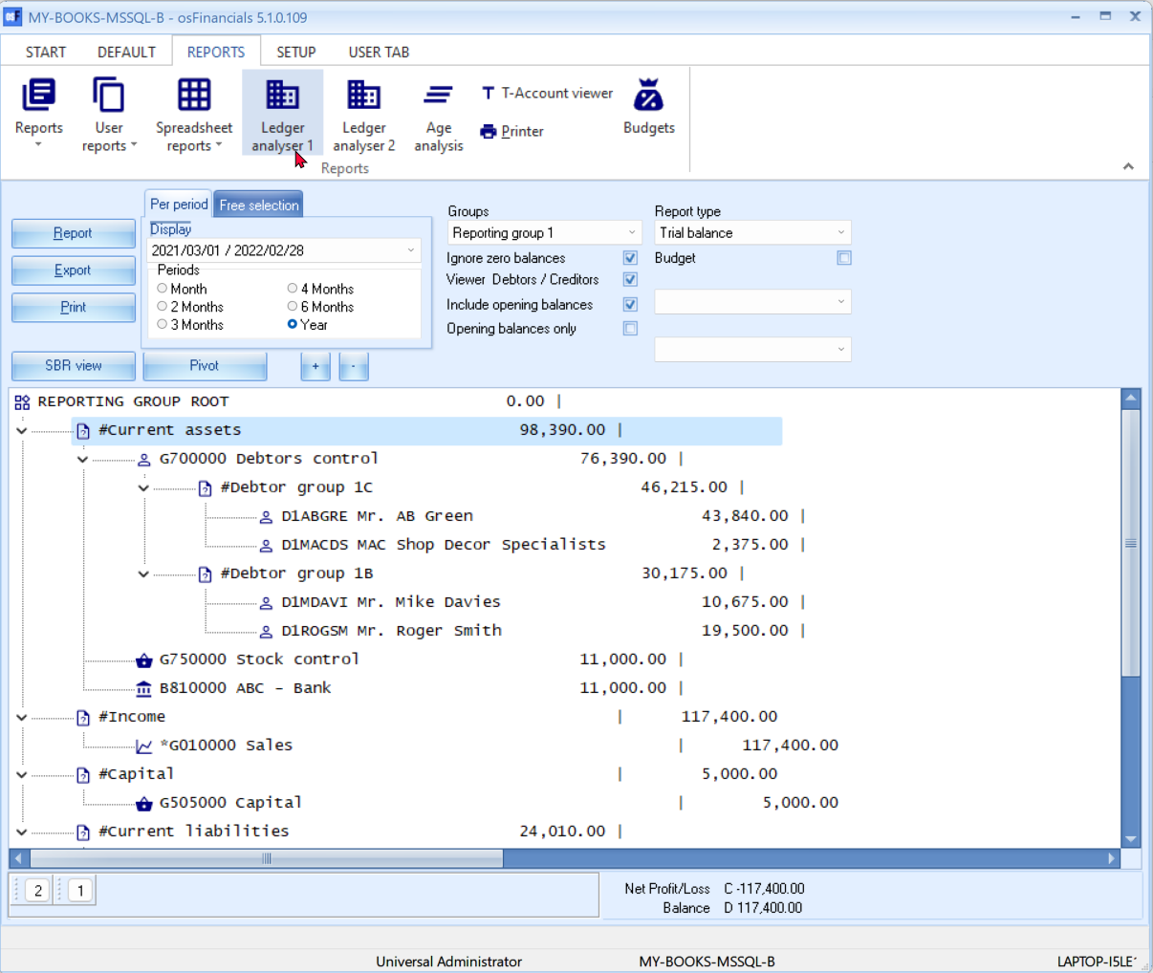

## Glass

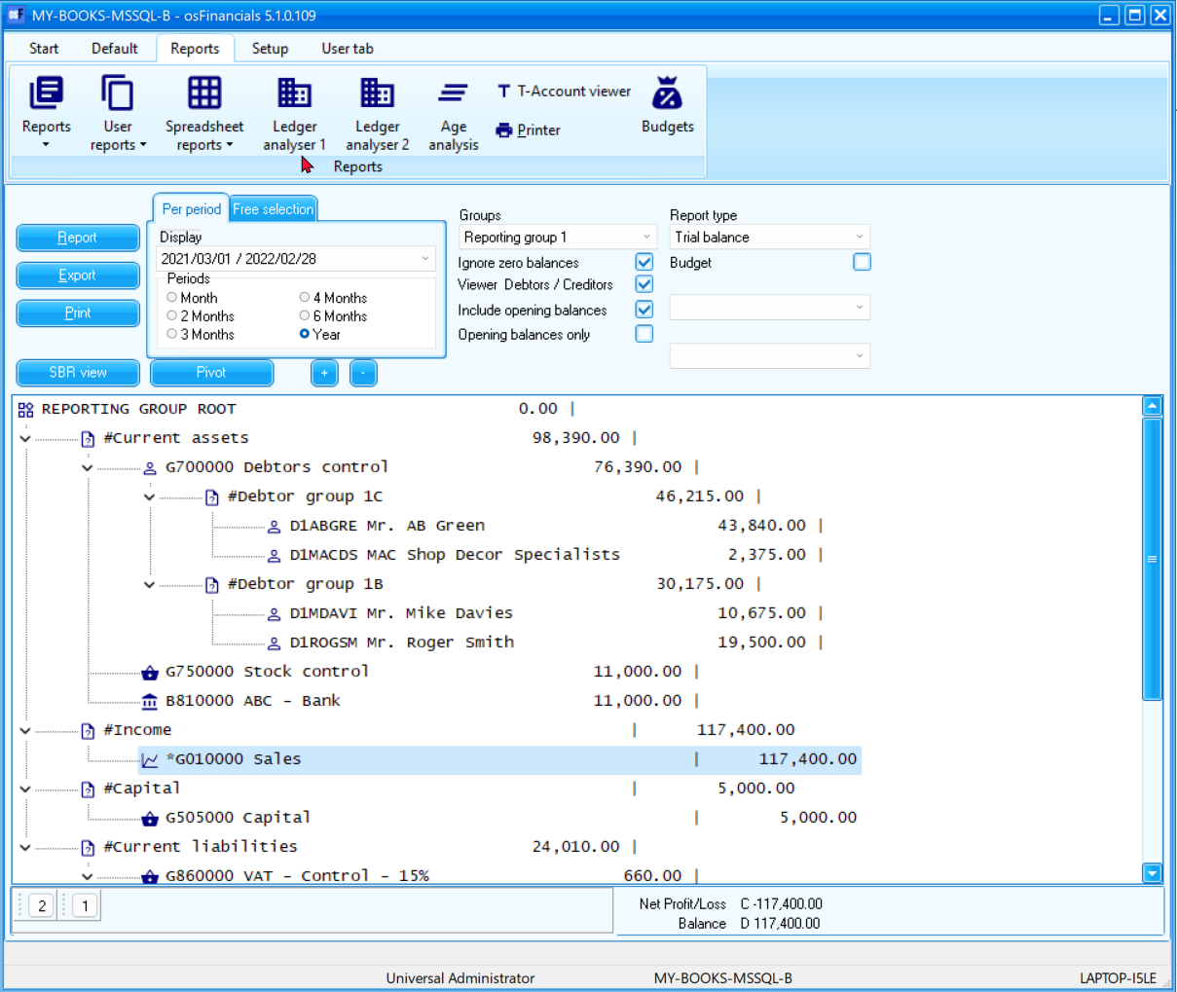

## Material

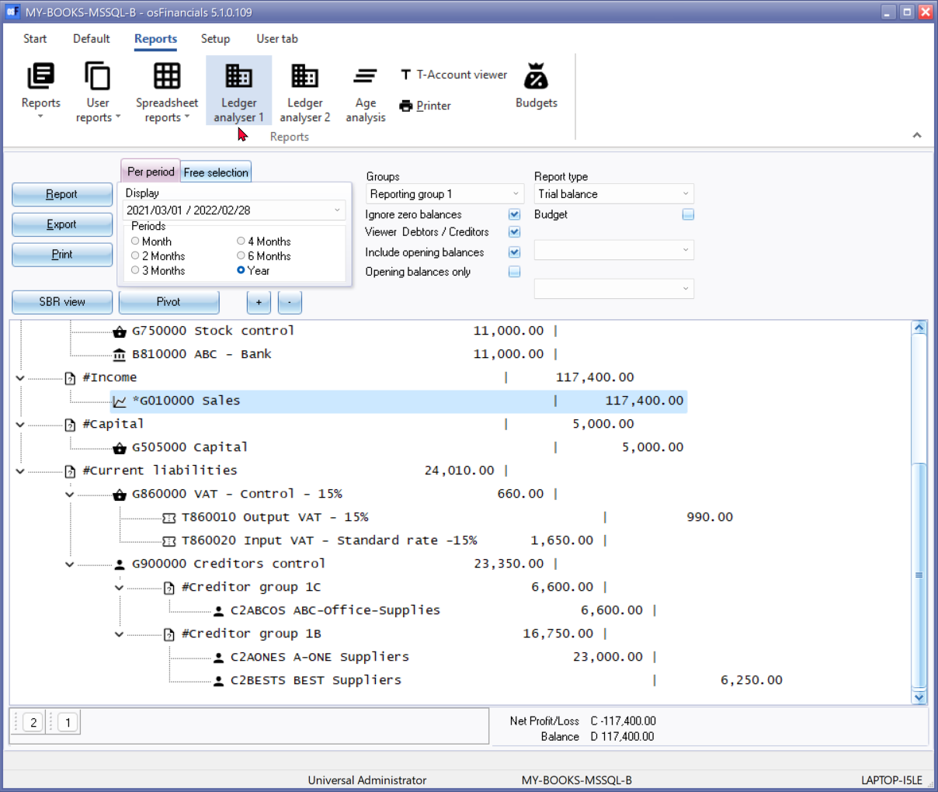

## Silver

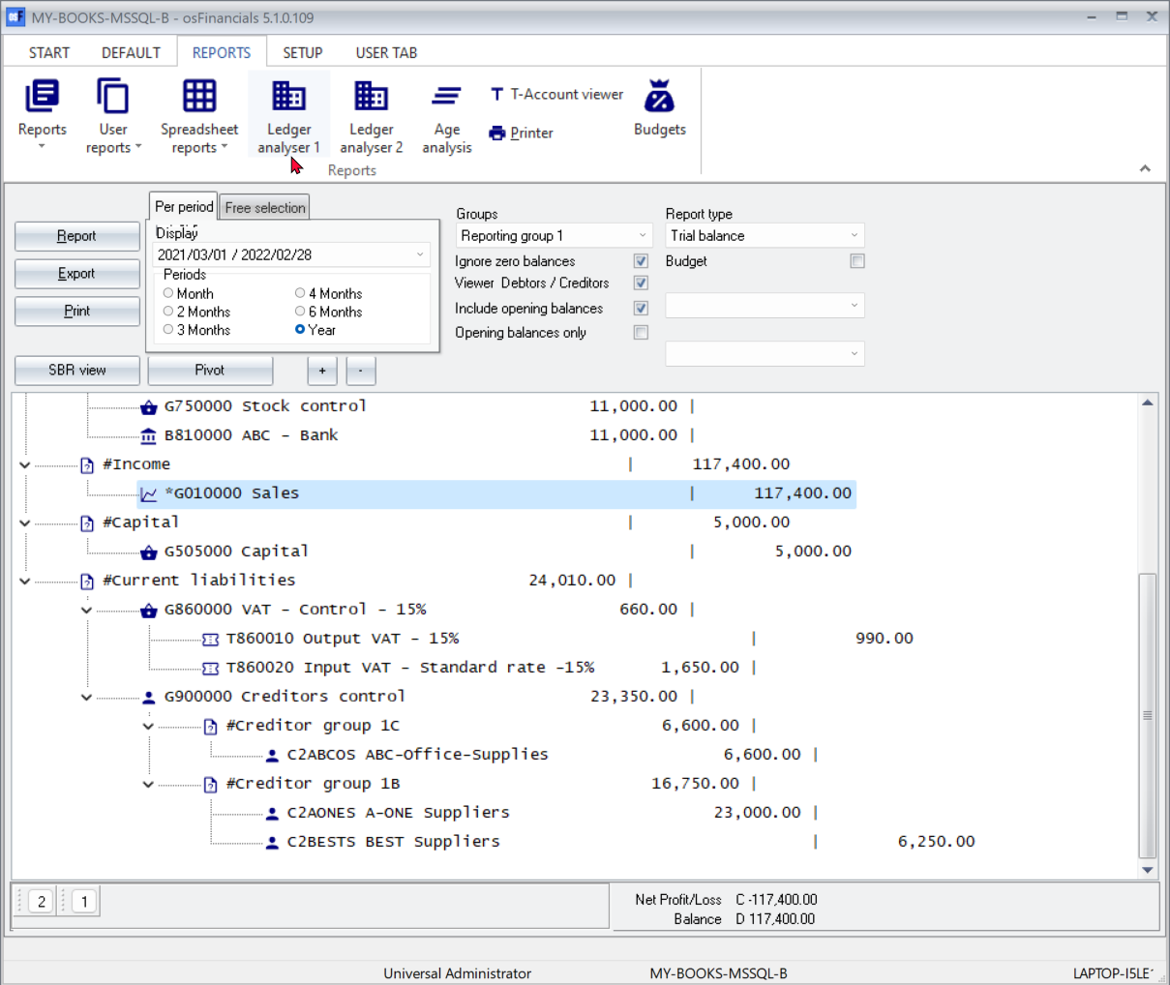

## Soft-blue

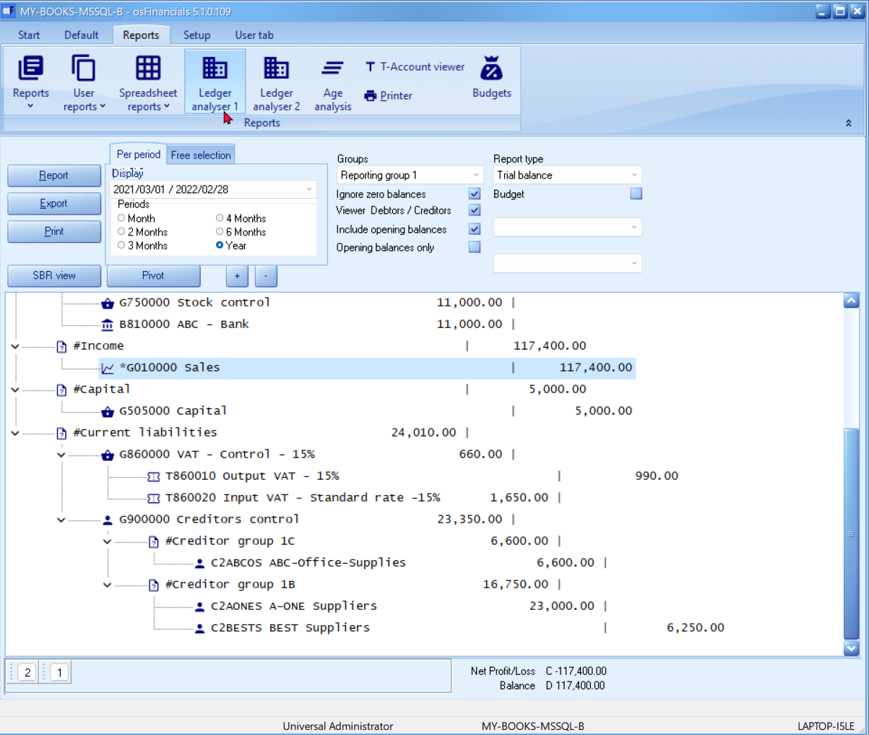

## VS2010

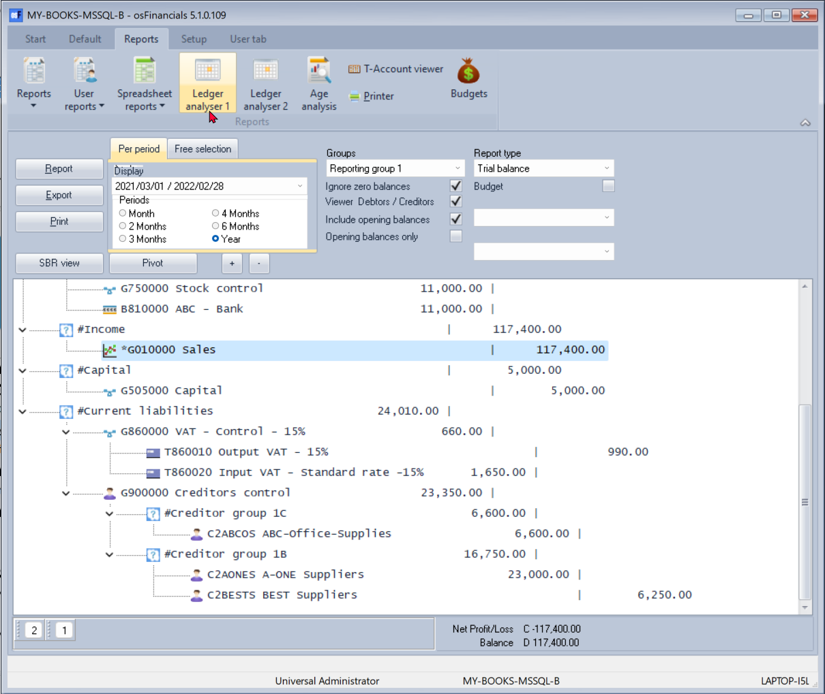

# *New Themes*

## Caramel

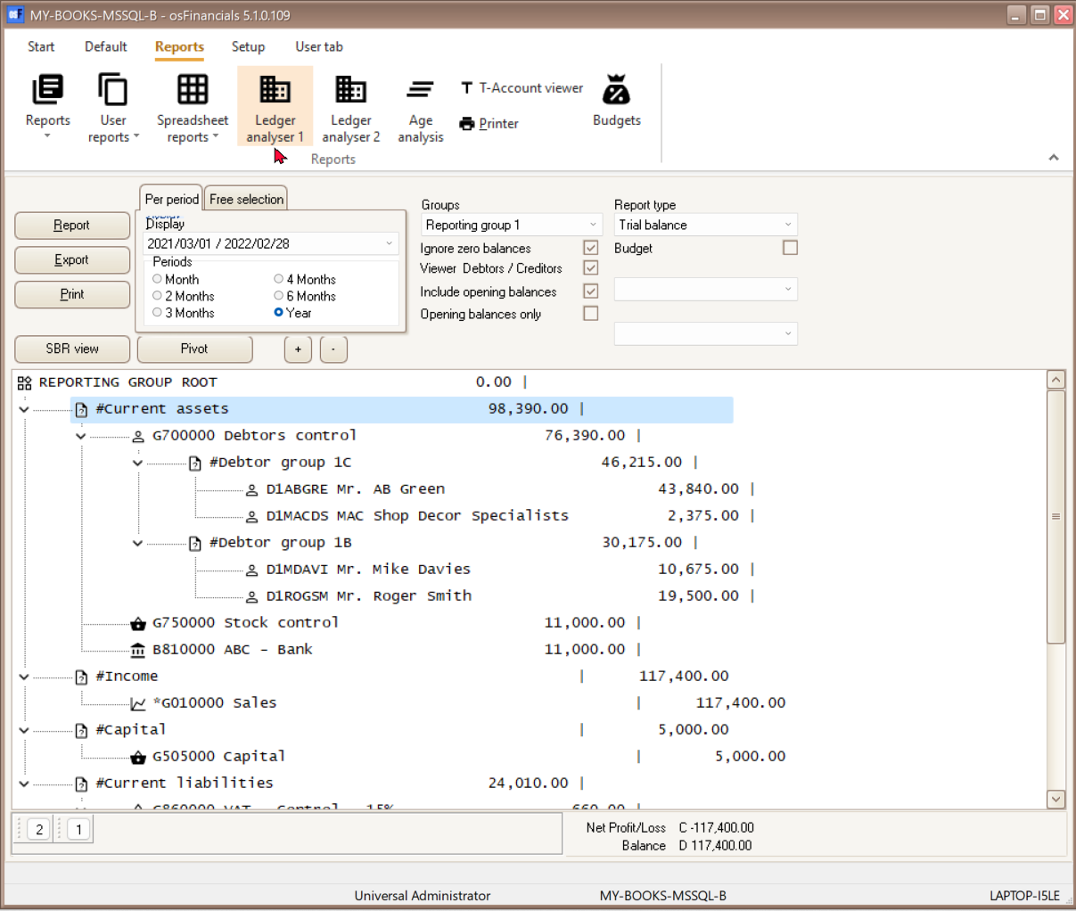

## Coffee

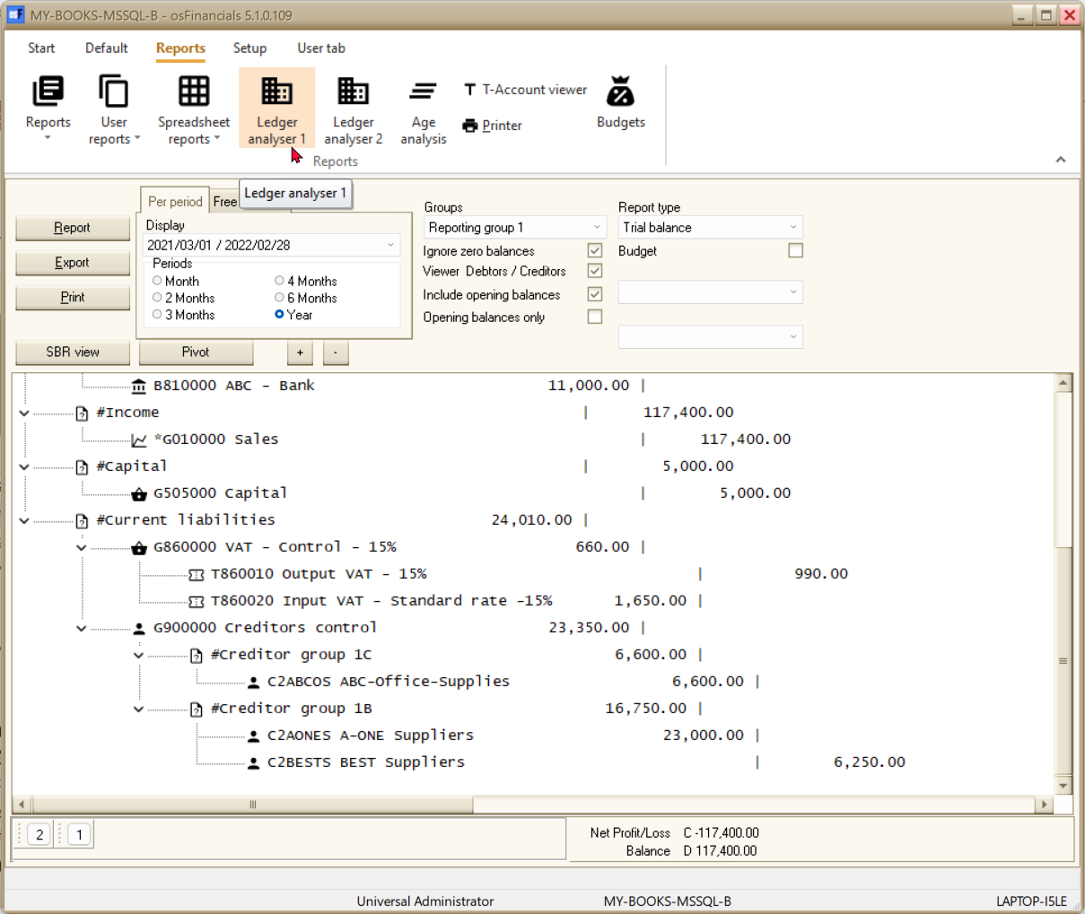

## DevExpressStyle

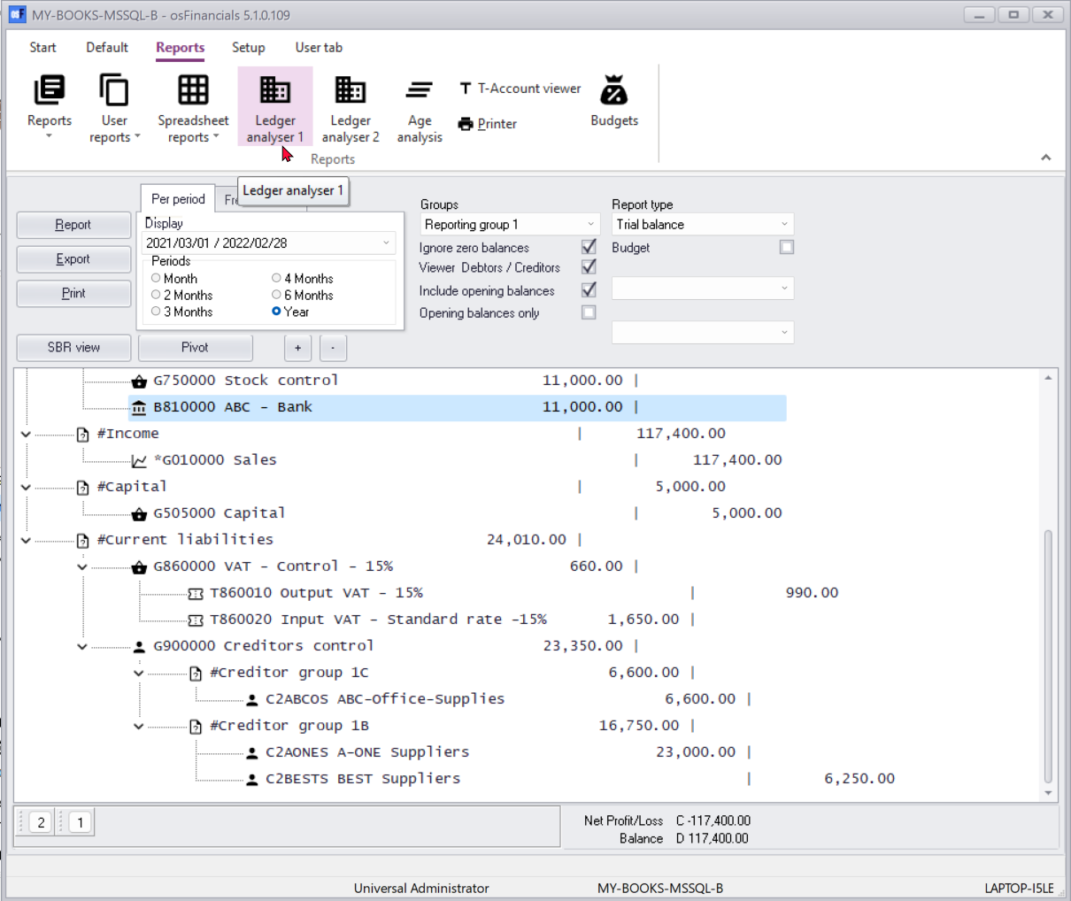

## Foggy

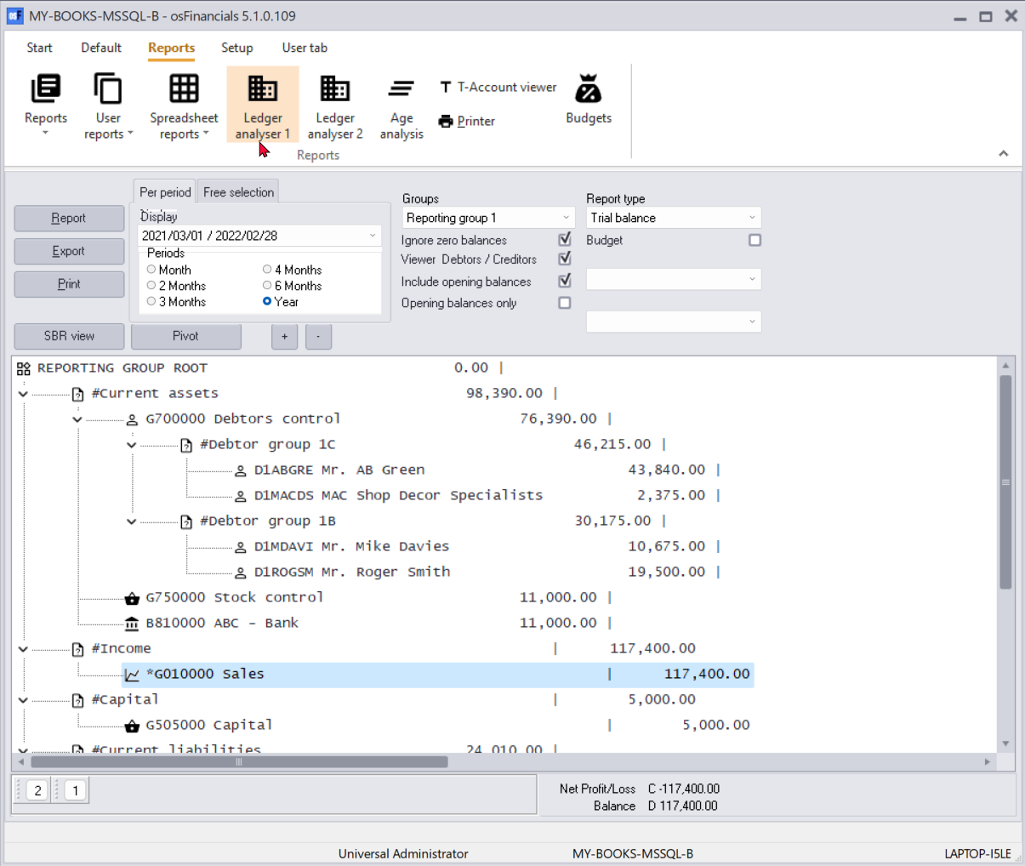

## iMaginery

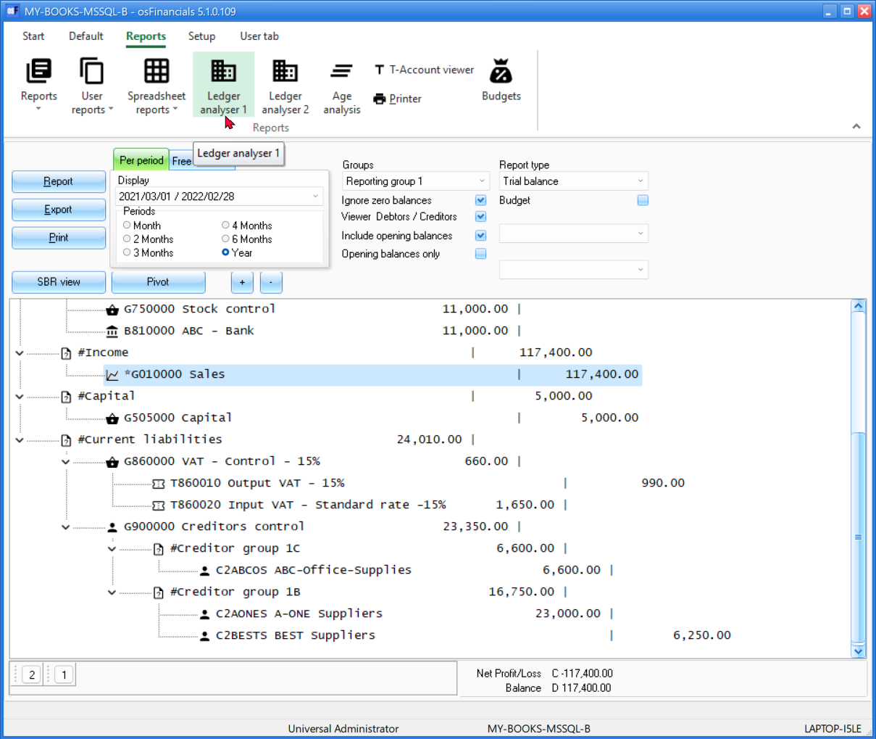

## Lilian



## LiquidSky

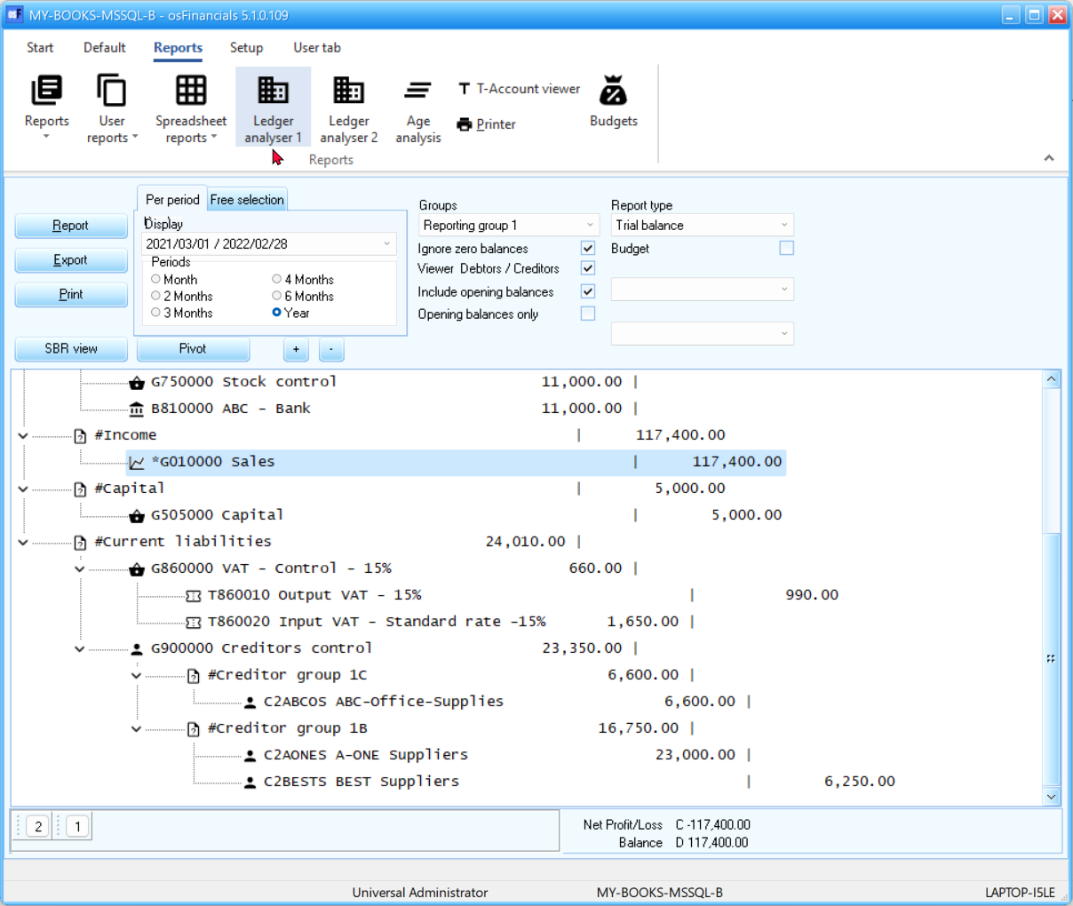

## LondonLiquidSky

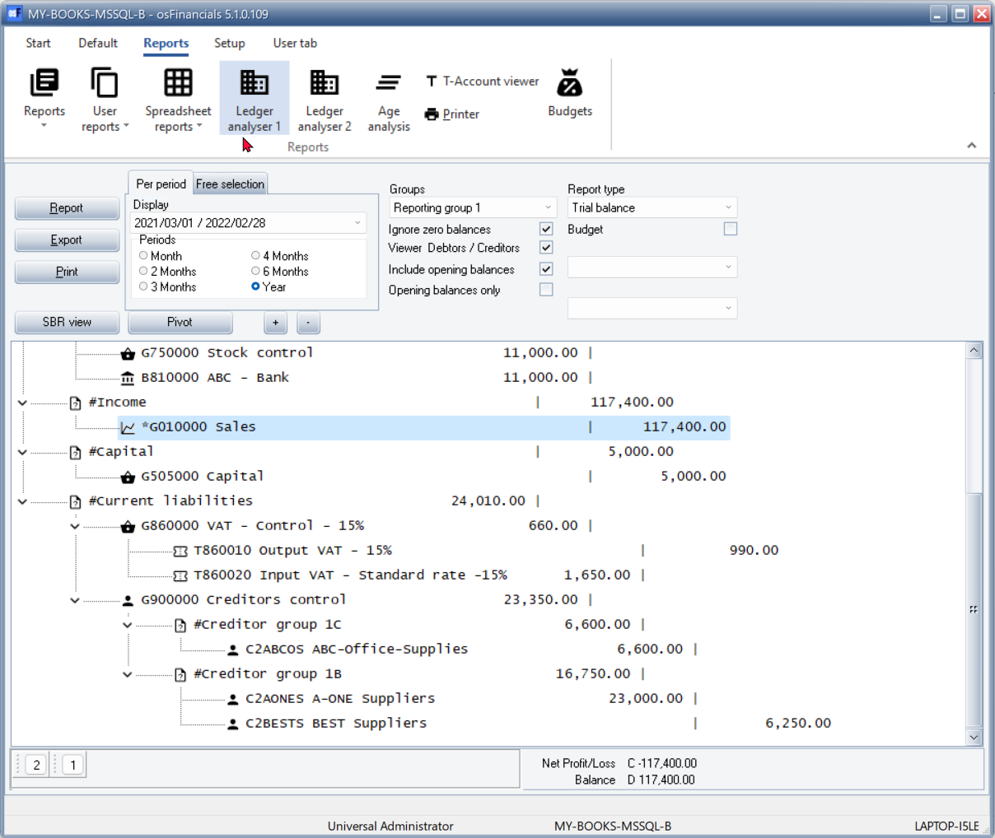

## Material-Black

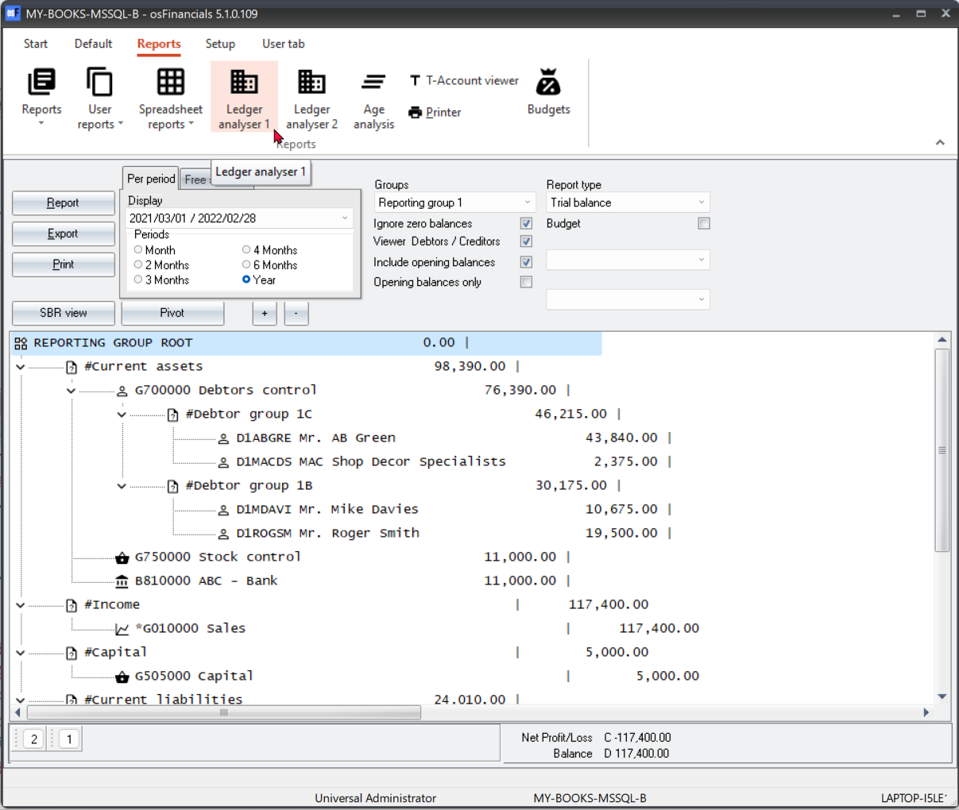

## Material-Blue

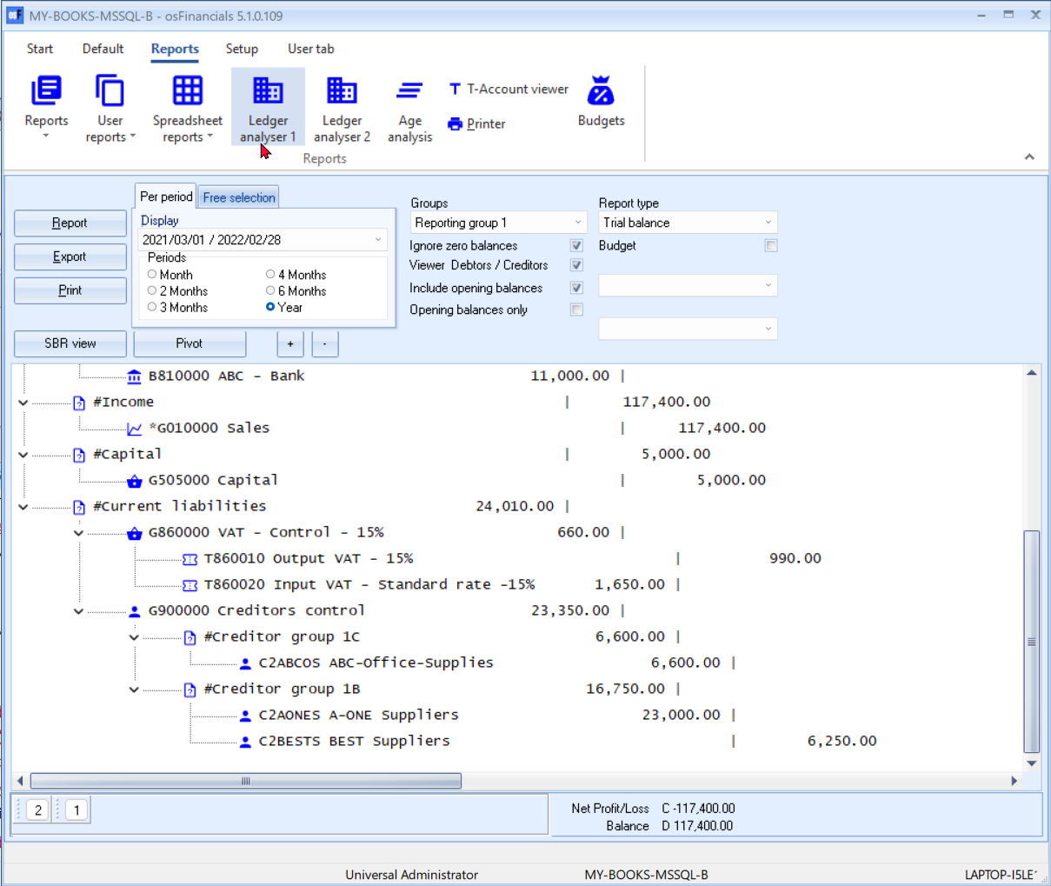

## Material-Green

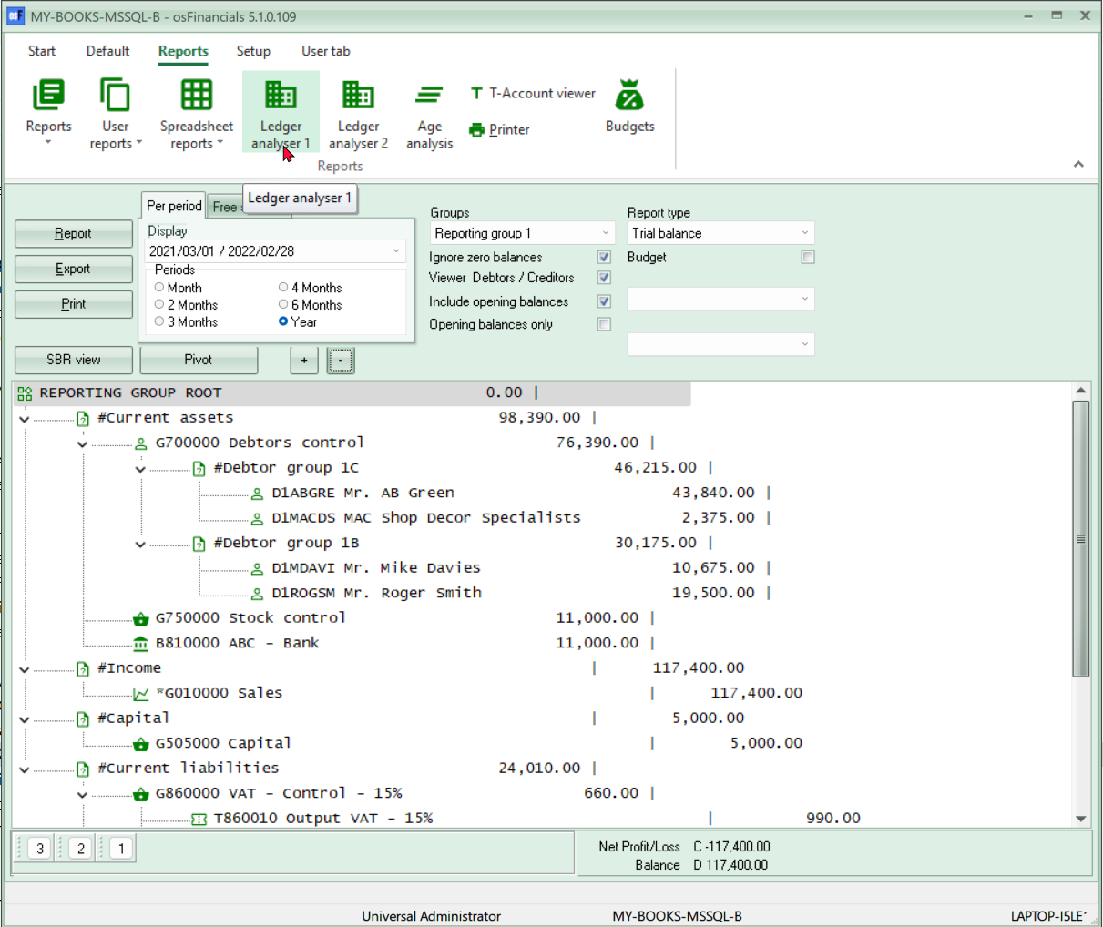

## Material-Maroon

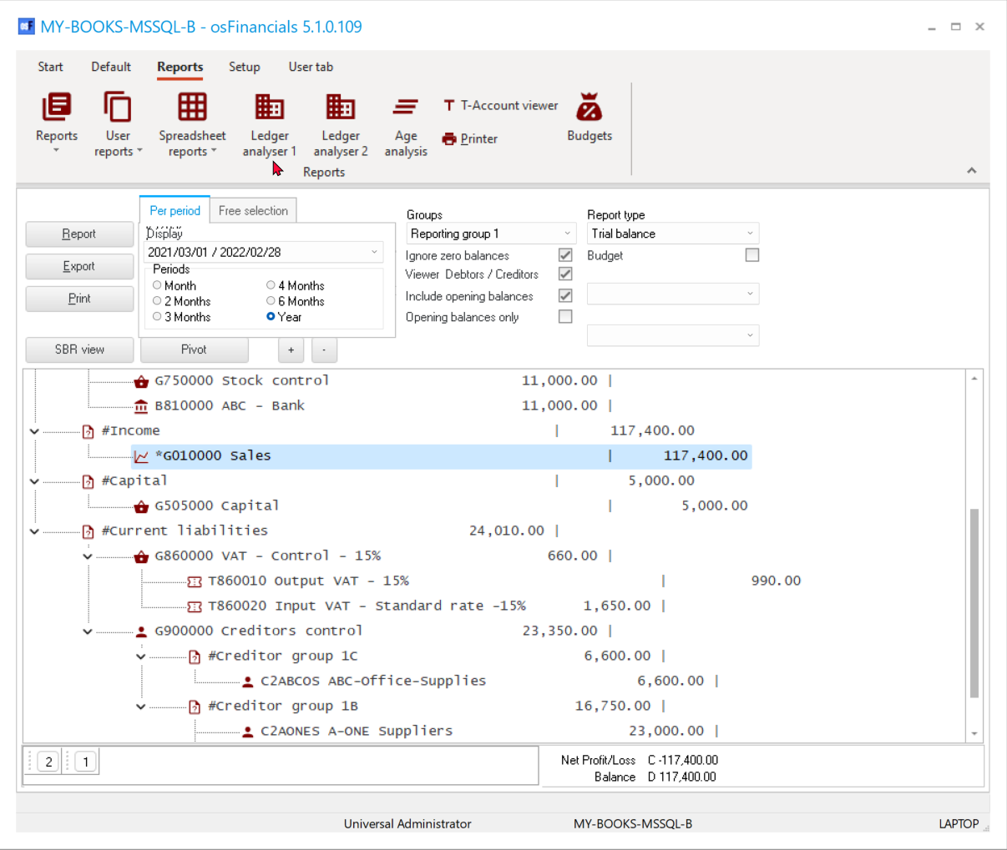

## Material-Navy

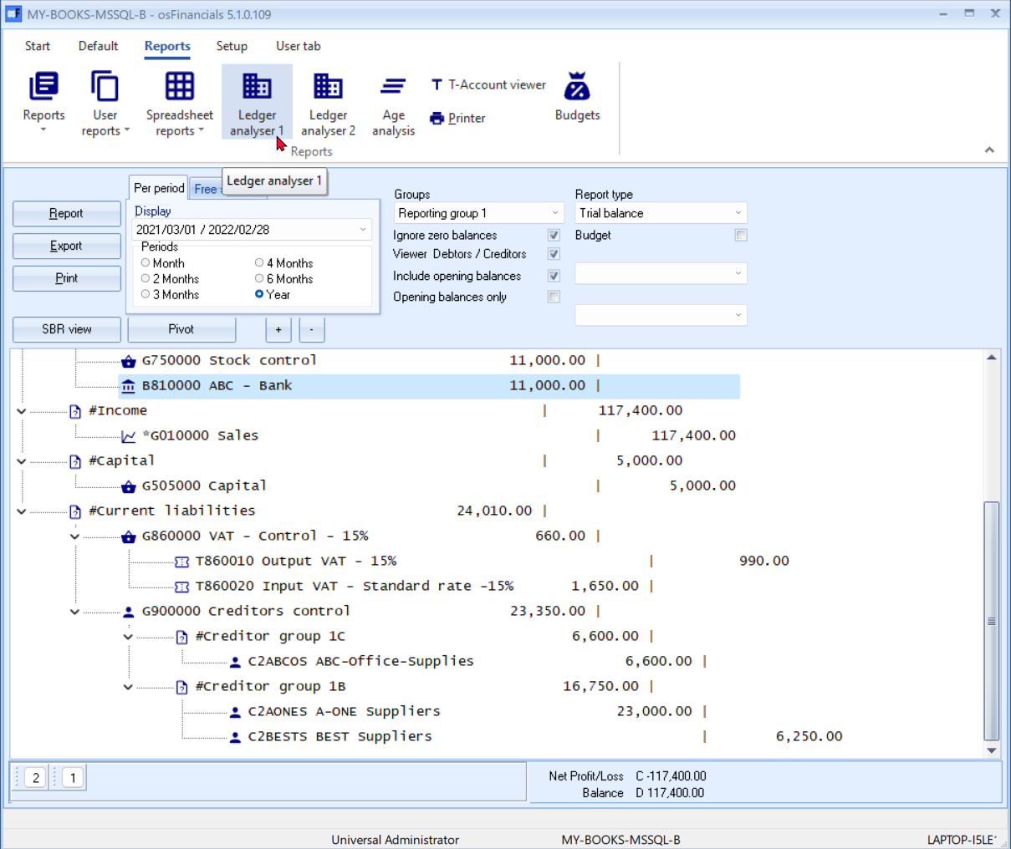

## Material-Pink

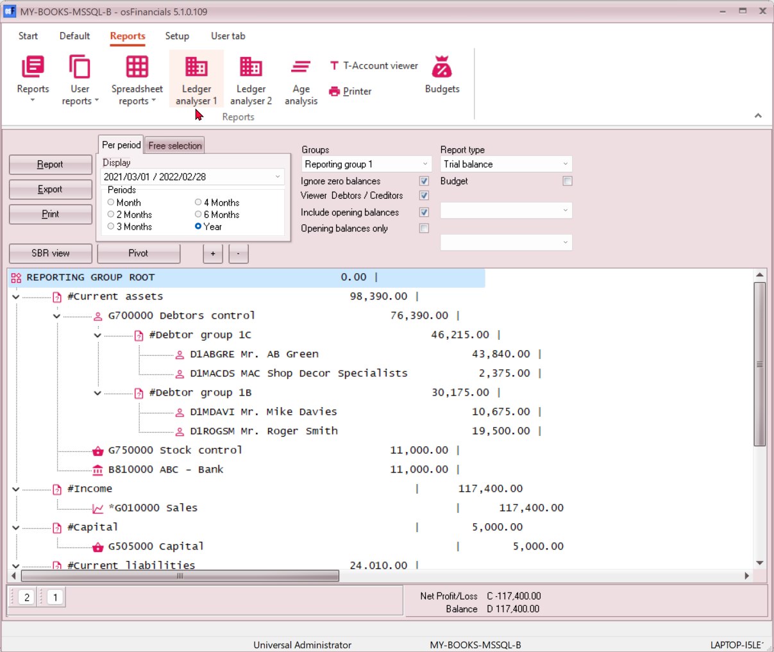

## Material-White

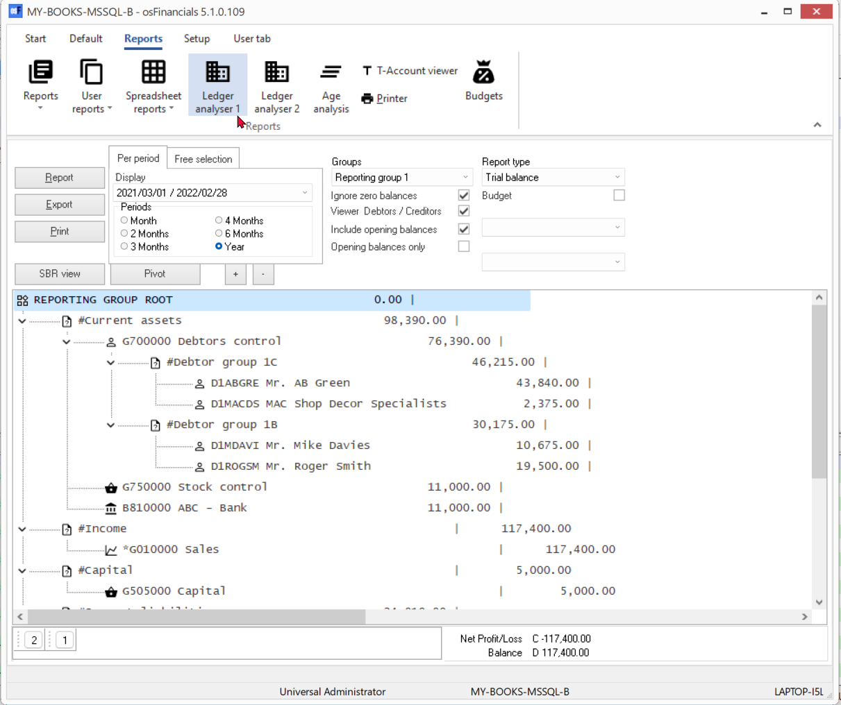

## McSkin

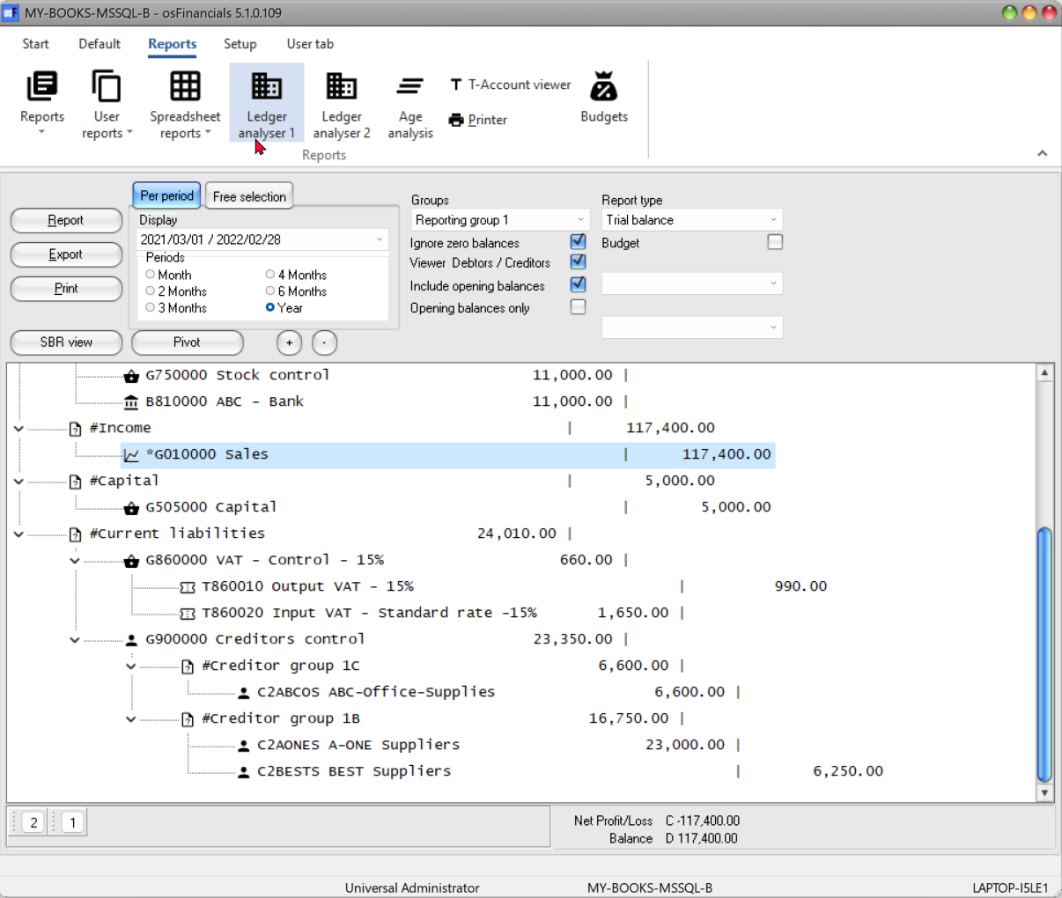

## Metropolis

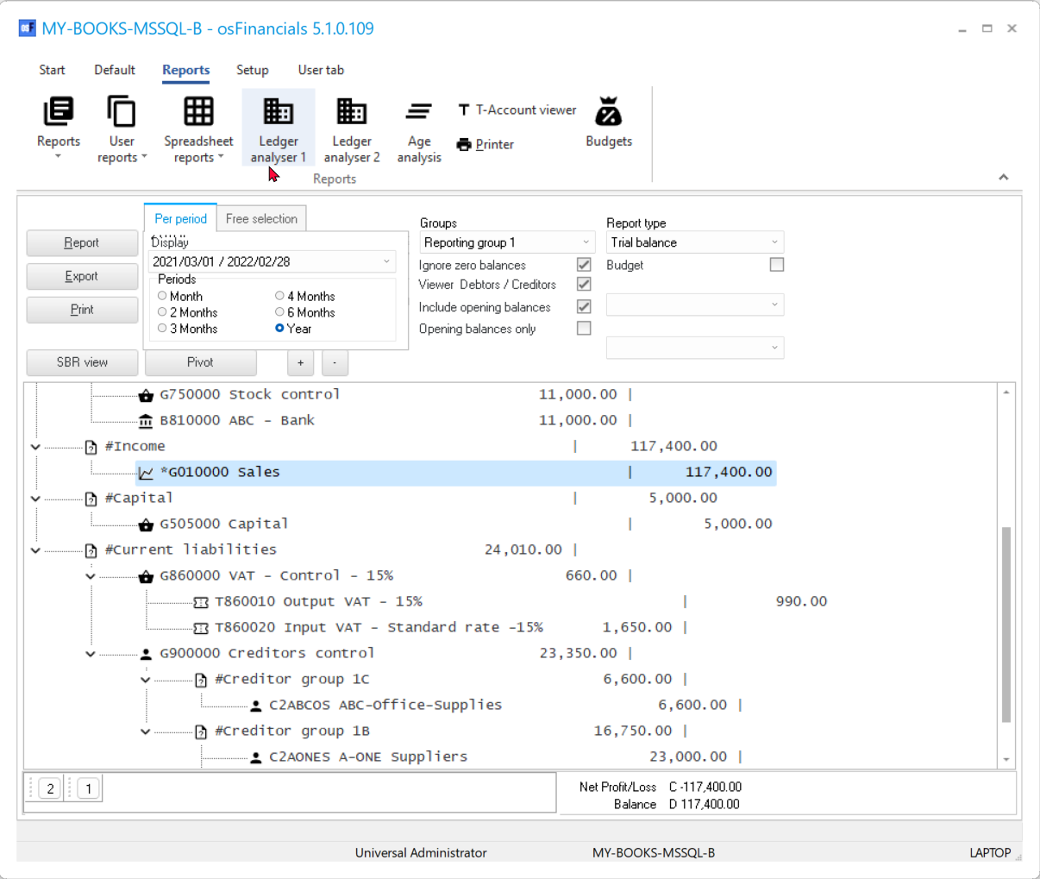

## MoneyTwins

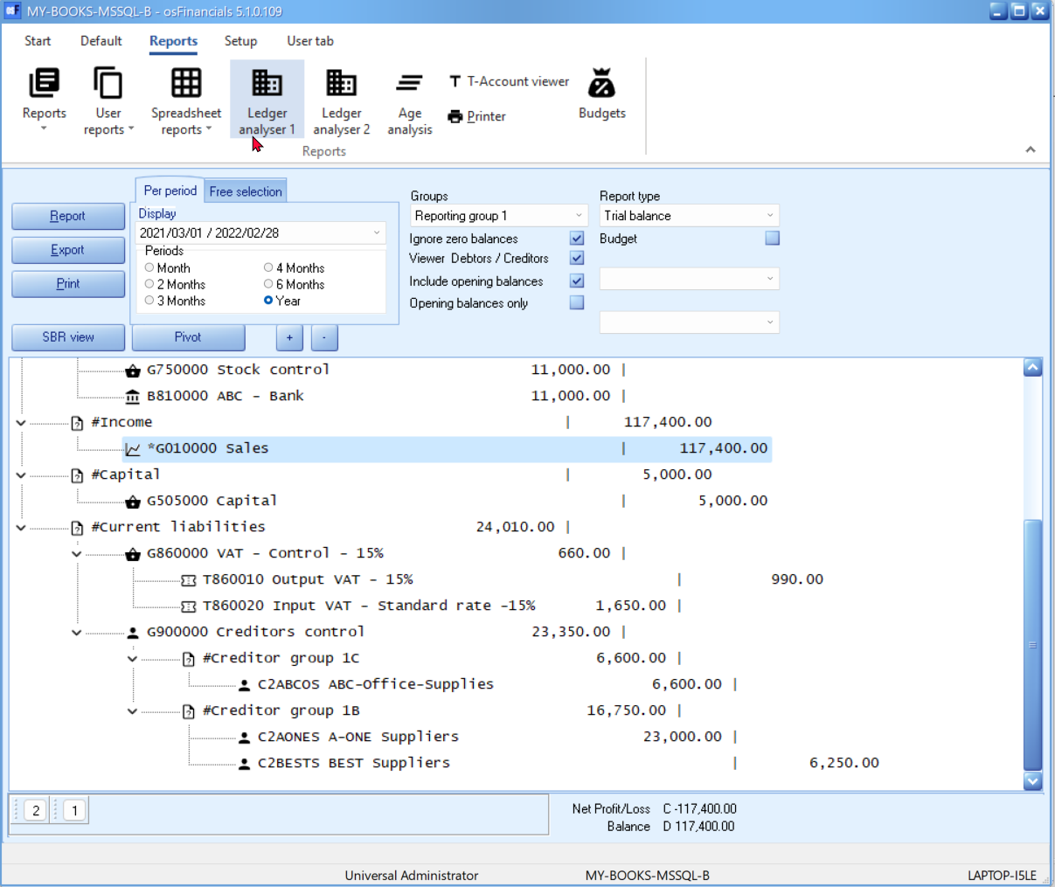

## Seven

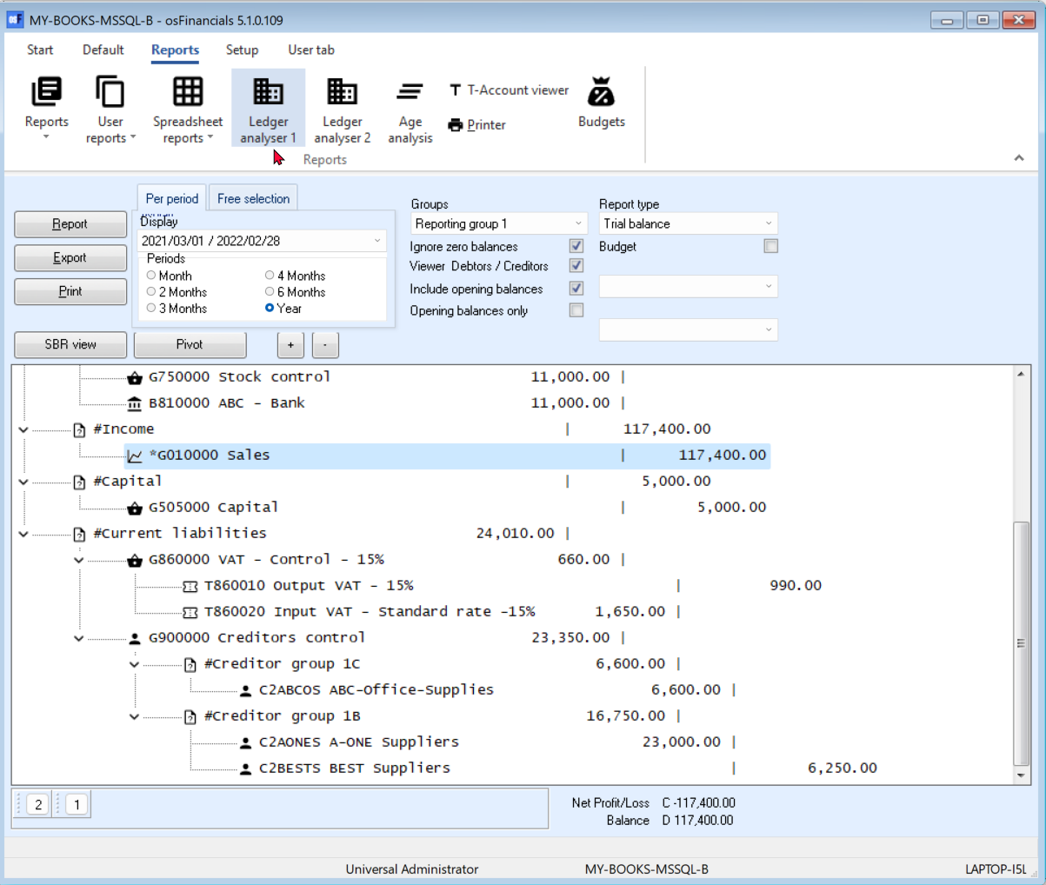

## SevenClassic

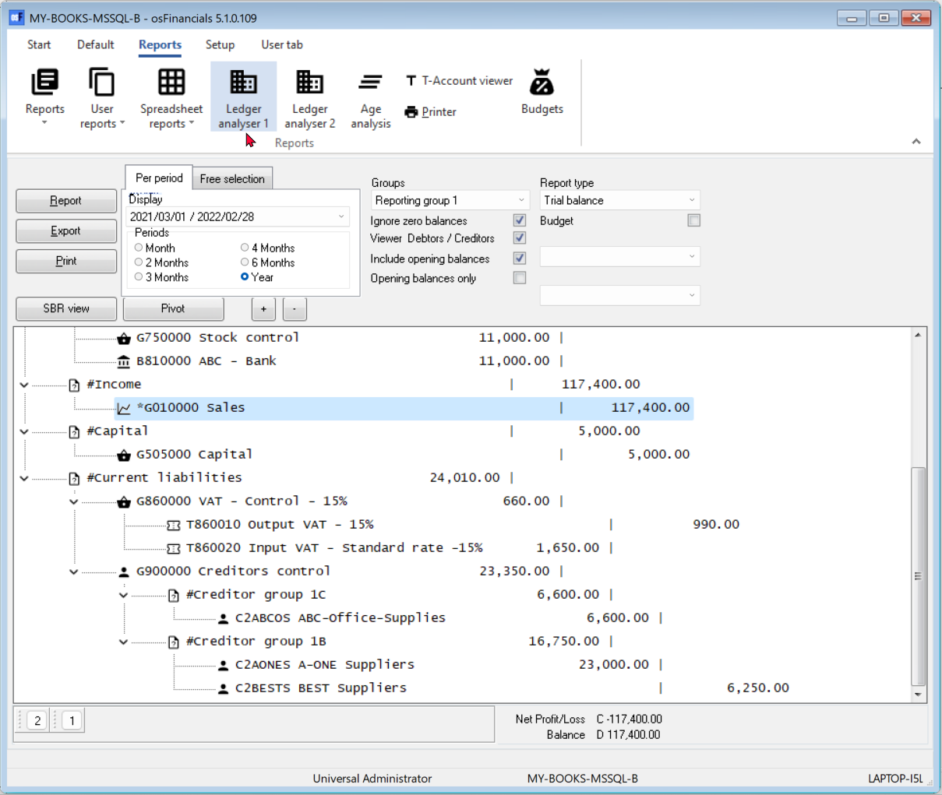

## Springtime

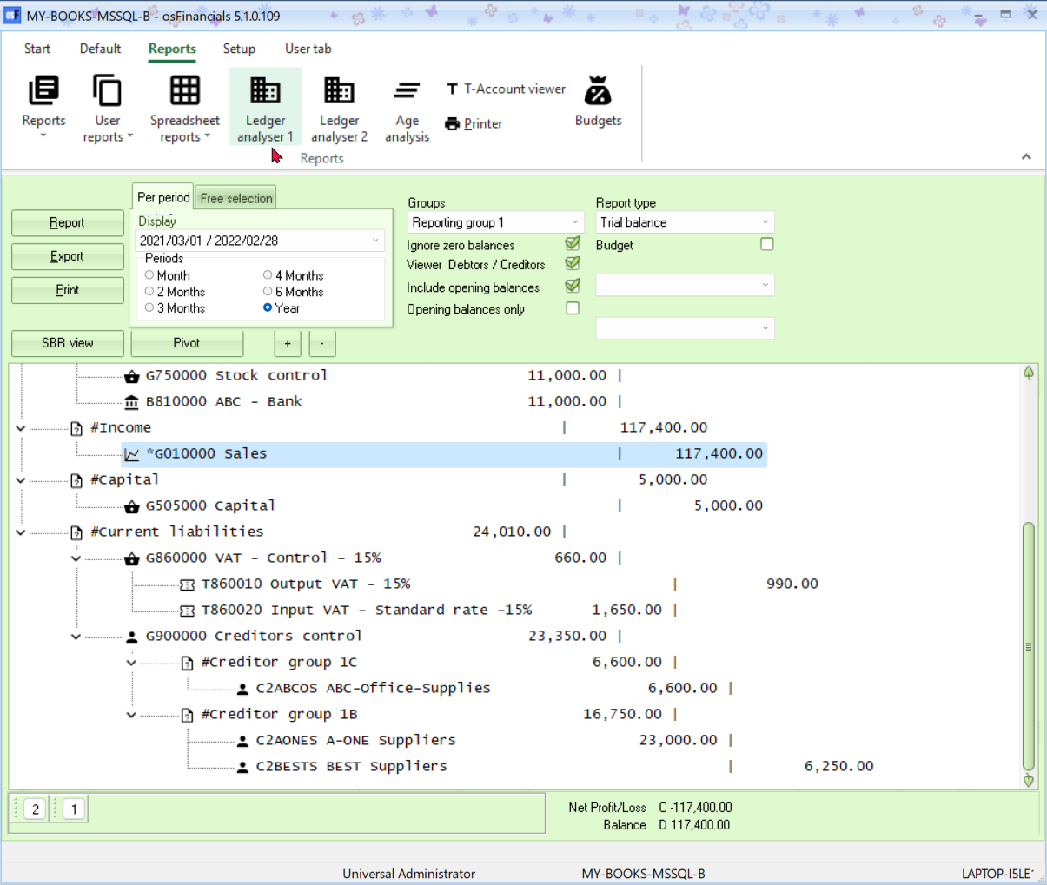

## Stardust

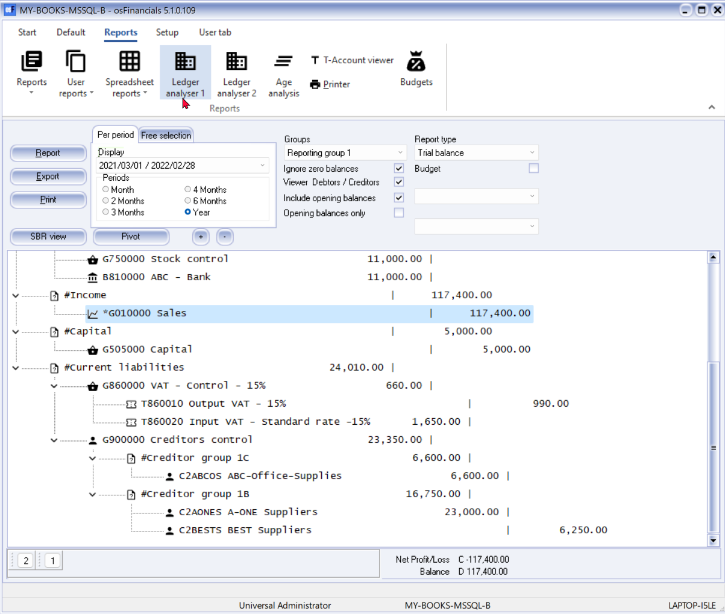

## Summertime

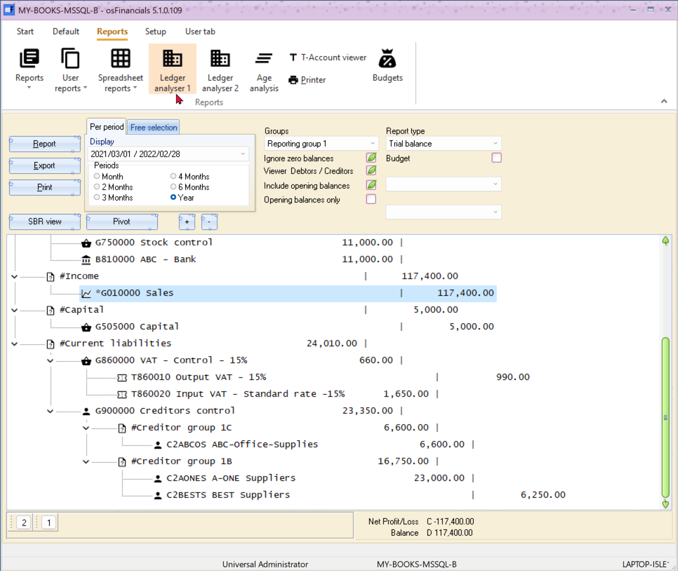

## TheBezier

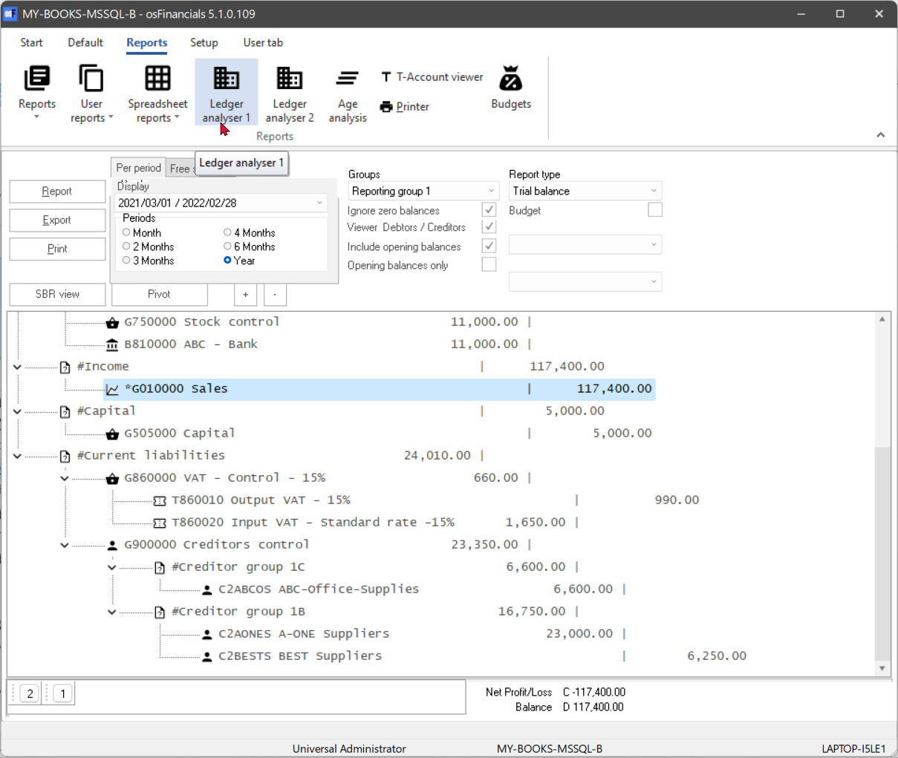

## TheAsphaltWorld

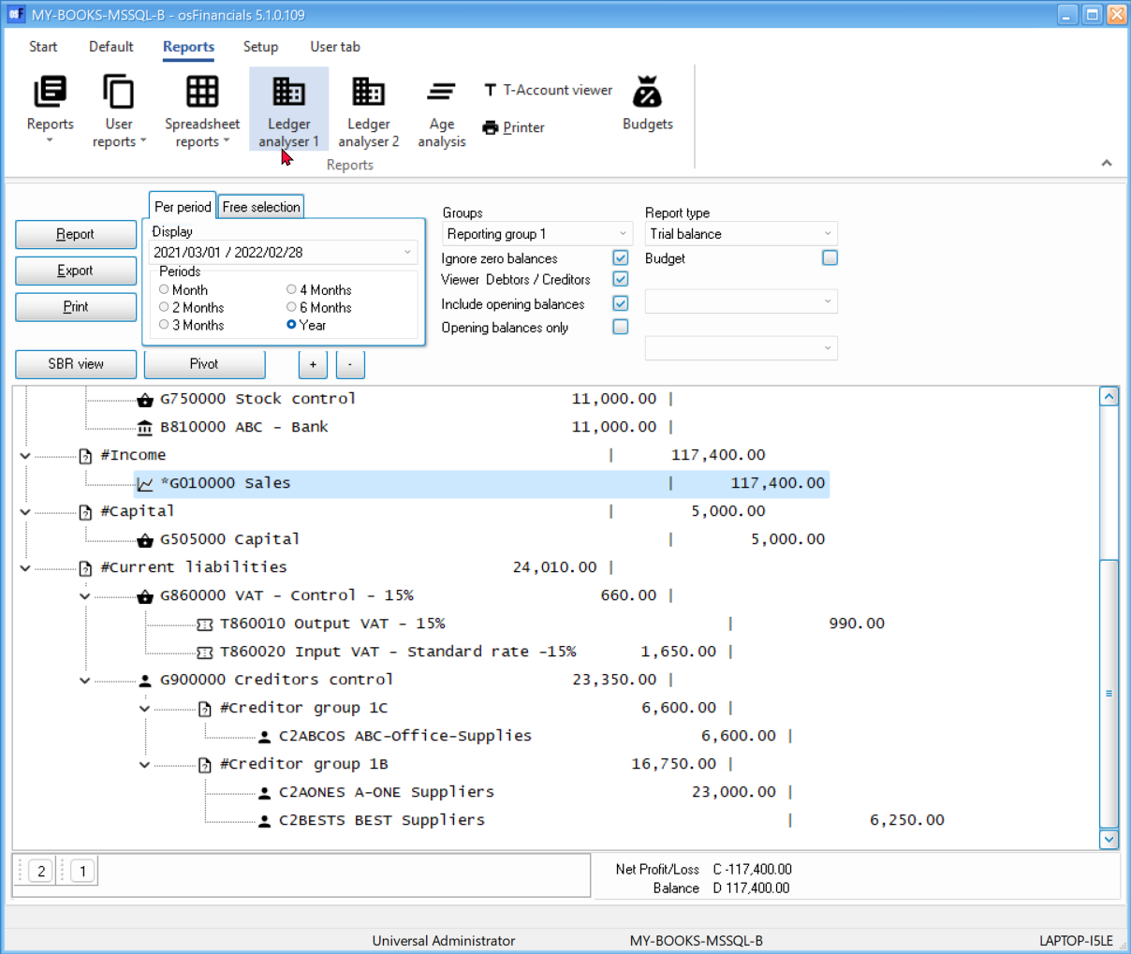

## Valentine

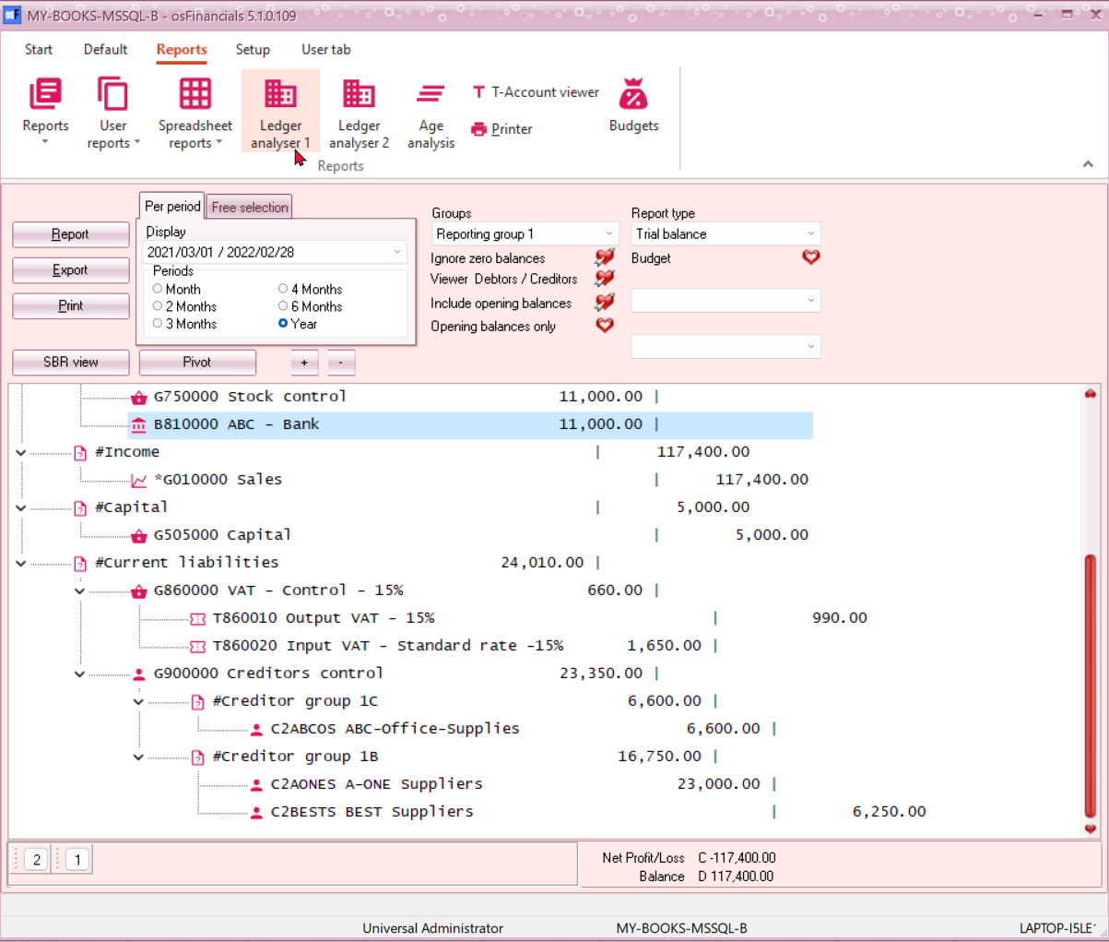

## WhitePrint

